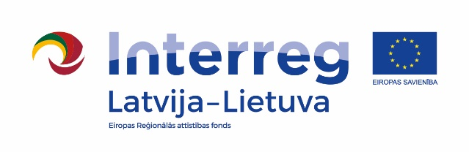
Interreg V-A Latvijas – Lietuvas pārrobežu sadarbības programmas 2014. – 2020.gadam
„Amatu prasmes tūrisma telpā“ /Tour de Crafts, Nr.LLI-539/
CREATIVE WORKSHOP IN BALVI
24th – 26th of November / Balvi, Bērzpils iela 62c
24th of November |  |  | 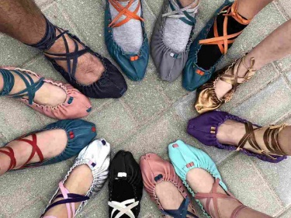  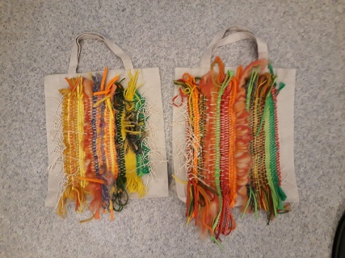  www.creativeideas.lv
11:00-13:00 | Riga Technical University docent Agrita Krieviņa – Siliņa  Lecture "Art and its meaning"
13:00-13:30 | Lunch break
13:30-15:00 | Riga Technical University docent Agrita Krieviņa – Siliņa  Lecture "Design and its meaning"
15:00-15:10 | Coffee break
15:10-15:40 | Member of the Board of the association "Creative Ideas"  Anita Kairiša  Presentation "Packaging Design"
15:40-17:00 | Anita Kairiša  Creative workshop “Application of craft skills in packaging design “
17:00-17:10 | Coffee break
17:10-19:20 | Anita Kairiša  Creative workshop “Application of craft skills in packaging design“
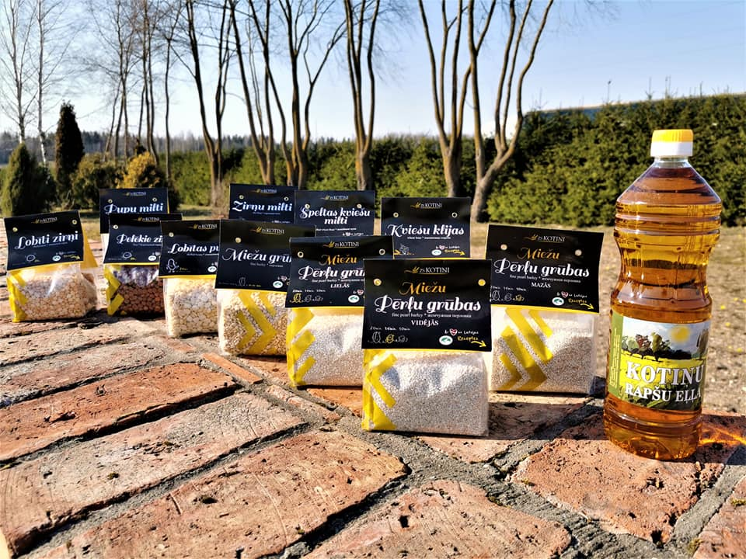  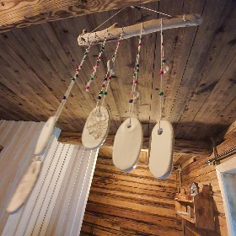  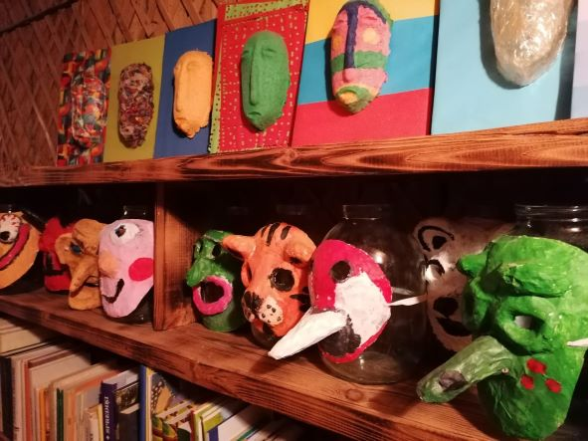 |  |  | 25th of November
 |  |  | 10:00-11:30 | farm "Kotiņi", lecture on packaging and product label design
 |  |  | 11:30-11:40 | Coffee break
 |  |  | 11:40-13:10 | Riga Technical University docent Agrita Krieviņa – Siliņa  Lecture "Traditional crafts in a modern vision"
 |  |  | 13:10-13:40 | Lunch break
 |  |  | 13:40-14:40 | Head of "Upītes" library and cultural history museum  Ligita Spridzāne  Presentation "Application of art and design in modern crafts"
 |  |  | 14:40-16:00 | Ligita Spridzāne  Creative workshop "Making gypsy masks"
 |  |  | 16:00-16:10 | Coffee break
 |  |  | 16:10-18:20 | Ligita Spridzāne  Creative workshop "Making gypsy masks"
26th of November |  |  | 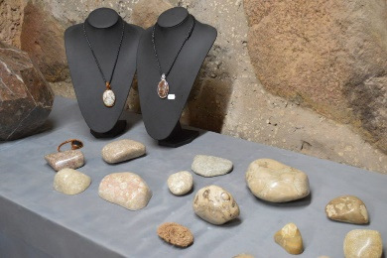  www.latvianminerals.com/lv
10:00 – 12:00 |  | SIA „Latvijas pusdārgakmeņi“,  lecture on "Semi-precious stone processing possibilities in the Baltics"
12:00 – 12:30 |  | Lunch Break | 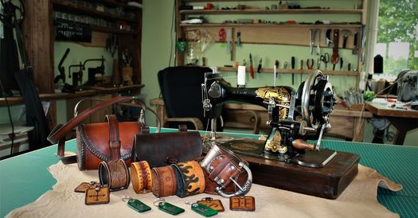  www.etsy.com/shop/LEATHERELY  www.instagram.com/leatherely/
12:30 – 14:00 |  | A practitioner of alternative education theories  Solvita Buša  Creative workshop „Making wind chimes“
14:00 – 15:30 |  | Leather craftsman Andris Ločmelis  Creative workshop "Leather processing methods in a modern vision"
15:30 – 16:00 |  | Discussion about the results of creative workshops

Working language of the event – Russian.
Important: project partners are asked to ensure that participants have a valid EU Digital COVID Certificate.

